Code-1.Upto Model Save :
# =========================================================
# INSTALL DEPENDENCIES
# =========================================================
!pip install -q timm albumentations==1.3.1 roboflow opencv-python

# =========================================================
# 1 IMPORTS & SETUP
# =========================================================
import os, glob, random
import numpy as np
from collections import Counter
from PIL import Image
from tqdm.auto import tqdm
import matplotlib.pyplot as plt

import torch
import torch.nn as nn
from torch.utils.data import Dataset, DataLoader, WeightedRandomSampler

import albumentations as A
from albumentations.pytorch import ToTensorV2

from sklearn.model_selection import train_test_split
from sklearn.metrics import accuracy_score, classification_report

import timm
from roboflow import Roboflow

device = "cuda" if torch.cuda.is_available() else "cpu"
torch.manual_seed(42)
np.random.seed(42)
random.seed(42)
print("🔥 Device:", device)

# =========================================================
# 2 DOWNLOAD DATASET (ROBOFLOW)
# =========================================================
rf = Roboflow(api_key="I2du50GUFMWkImaaH0Wm") # 🔴 PUT YOUR API KEY
project = rf.workspace("ahsan-khan-iw5ip").project("blood-group-detection-kmolp")
dataset = project.version(1).download("folder")
dataset_path = dataset.location

# =========================================================
# 3 LOAD DATA & STRATIFIED SPLIT (70 / 15 / 15)
# =========================================================
def load_all_data(path):
files, labels = [], []
classes = sorted(os.listdir(os.path.join(path, "train")))
for i, cls in enumerate(classes):
for split in ["train", "valid", "test"]:
p = os.path.join(path, split, cls)
if os.path.exists(p):
imgs = glob.glob(p + "/*")
files.extend(imgs)
labels.extend([i] * len(imgs))
return files, labels, classes

files, labels, classes = load_all_data(dataset_path)

X_train, X_tmp, y_train, y_tmp = train_test_split(
files, labels, test_size=0.30, stratify=labels, random_state=42
)
X_val, X_test, y_val, y_test = train_test_split(
X_tmp, y_tmp, test_size=0.50, stratify=y_tmp, random_state=42
)

# =========================================================
# 📊 CLASS-WISE DISTRIBUTION DISPLAY
# =========================================================
def show_distribution(name, y, classes):
cnt = Counter(y)
print(f"\n{name} SET: {len(y)} samples")
for i, cls in enumerate(classes):
print(f" {cls}: {cnt[i]}")

print("\n================ DATASET SPLIT DISTRIBUTION ================")
show_distribution("TRAIN", y_train, classes)
show_distribution("VALIDATION", y_val, classes)
show_distribution("TEST", y_test, classes)
print("============================================================")

# =========================================================
# 4 DATA AUGMENTATION
# =========================================================
IMG = 224

train_tfms = A.Compose([
A.Resize(256, 256),
A.CenterCrop(IMG, IMG),
A.HorizontalFlip(p=0.5),
A.RandomBrightnessContrast(p=0.4),
A.Normalize(),
ToTensorV2()
])

val_tfms = A.Compose([
A.Resize(256, 256),
A.CenterCrop(IMG, IMG),
A.Normalize(),
ToTensorV2()
])

# =========================================================
# 5 DATASET & DATALOADERS
# =========================================================
class FingerprintDataset(Dataset):
def __init__(self, files, labels, tfm):
self.files, self.labels, self.tfm = files, labels, tfm
def __len__(self): return len(self.files)
def __getitem__(self, i):
img = np.array(Image.open(self.files[i]).convert("RGB"))
img = self.tfm(image=img)["image"]
return img, torch.tensor(self.labels[i])

cnt = Counter(y_train)
weights = [1.0 / cnt[l] for l in y_train]
sampler = WeightedRandomSampler(weights, len(weights), replacement=True)

train_dl = DataLoader(
FingerprintDataset(X_train, y_train, train_tfms),
batch_size=16, sampler=sampler, num_workers=2, pin_memory=True
)
val_dl = DataLoader(
FingerprintDataset(X_val, y_val, val_tfms),
batch_size=32, num_workers=2, pin_memory=True
)
test_dl = DataLoader(
FingerprintDataset(X_test, y_test, val_tfms),
batch_size=32, num_workers=2, pin_memory=True
)

# =========================================================
# 6 STRONG HYBRID MODEL
# =========================================================
class StrongHybrid(nn.Module):
def __init__(self, n):
super().__init__()
self.eff = timm.create_model("tf_efficientnetv2_s.in21k", pretrained=True, num_classes=0)
self.cnx = timm.create_model("convnext_small", pretrained=True, num_classes=0)
self.bn1 = nn.BatchNorm1d(self.eff.num_features)
self.bn2 = nn.BatchNorm1d(self.cnx.num_features)
self.head = nn.Sequential(
nn.Linear(self.eff.num_features + self.cnx.num_features, 1024),
nn.BatchNorm1d(1024),
nn.GELU(),
nn.Dropout(0.35),
nn.Linear(1024, n)
)

def forward(self, x):
f1 = self.bn1(self.eff(x))
f2 = self.bn2(self.cnx(x))
return self.head(torch.cat([f1, f2], dim=1))

model = StrongHybrid(len(classes)).to(device)
print("✅ Model initialized")

# =========================================================
#7 LOSS, OPTIMIZER, SCHEDULER
# =========================================================
class_weights = torch.tensor([1.0 / cnt[i] for i in range(len(classes))], device=device)

criterion = nn.CrossEntropyLoss(weight=class_weights, label_smoothing=0.05)

optimizer = torch.optim.AdamW(model.parameters(), lr=3e-4, weight_decay=1e-4)

scheduler = torch.optim.lr_scheduler.CosineAnnealingWarmRestarts(
optimizer, T_0=10, T_mult=2, eta_min=1e-6
)

scaler = torch.cuda.amp.GradScaler()

# =========================================================
# 8 TRAINING (STORE ACC & LOSS)
# =========================================================
EPOCHS = 70
patience, wait = 10, 0
best_val_acc = 0.0

train_acc_hist, val_acc_hist = [], []
train_loss_hist, val_loss_hist = [], []

for epoch in range(EPOCHS):
model.train()
tr_p, tr_y = [], []
train_loss = 0.0

for x, y in tqdm(train_dl, desc=f"Epoch {epoch+1}/{EPOCHS}"):
x, y = x.to(device), y.to(device)
optimizer.zero_grad()

with torch.cuda.amp.autocast():
out = model(x)
loss = criterion(out, y)

scaler.scale(loss).backward()
scaler.step(optimizer)
scaler.update()

train_loss += loss.item()
tr_p += out.argmax(1).cpu().tolist()
tr_y += y.cpu().tolist()

scheduler.step()
train_loss /= len(train_dl)
train_acc = accuracy_score(tr_y, tr_p)

model.eval()
v_p, v_y = [], []
val_loss = 0.0

with torch.no_grad():
for x, y in val_dl:
x, y = x.to(device), y.to(device)
out = model(x)
loss = criterion(out, y)
val_loss += loss.item()
v_p += out.argmax(1).cpu().tolist()
v_y += y.cpu().tolist()

val_loss /= len(val_dl)
val_acc = accuracy_score(v_y, v_p)

train_acc_hist.append(train_acc)
val_acc_hist.append(val_acc)
train_loss_hist.append(train_loss)
val_loss_hist.append(val_loss)

print(f"📊 Epoch {epoch+1}: TrainAcc={train_acc:.4f}, ValAcc={val_acc:.4f}")

if val_acc > best_val_acc:
best_val_acc = val_acc
wait = 0
torch.save(model.state_dict(), "best_model.pth")
print("✅ Best model saved")
else:
wait += 1
if wait >= patience:
print("🛑 Early stopping")
break

# =========================================================
# 9 TEST-TIME AUGMENTATION (TTA)
# =========================================================
model.load_state_dict(torch.load("best_model.pth"))
model.eval()

tp, ty = [], []
with torch.no_grad():
for x, y in test_dl:
x, y = x.to(device), y.to(device)
o1 = model(x)
o2 = model(torch.flip(x, dims=[3]))
o = (o1 + o2) / 2
tp += o.argmax(1).cpu().tolist()
ty += y.cpu().tolist()

print("\n🎯 FINAL TEST ACCURACY:", accuracy_score(ty, tp))
print("\n📄 CLASSIFICATION REPORT:\n")
print(classification_report(ty, tp, target_names=classes))

# =========================================================
# 10 PLOT ACCURACY & LOSS
# =========================================================
epochs = range(1, len(train_acc_hist) + 1)

plt.figure(figsize=(8,5))
plt.plot(epochs, train_acc_hist, label="Train Accuracy")
plt.plot(epochs, val_acc_hist, label="Validation Accuracy")
plt.xlabel("Epochs")
plt.ylabel("Accuracy")
plt.title("Training vs Validation Accuracy")
plt.legend()
plt.grid(True)
plt.show()

plt.figure(figsize=(8,5))
plt.plot(epochs, train_loss_hist, label="Train Loss")
plt.plot(epochs, val_loss_hist, label="Validation Loss")
plt.xlabel("Epochs")
plt.ylabel("Loss")
plt.title("Training vs Validation Loss")
plt.legend()
plt.grid(True)
plt.show()

# =========================================================
# 11 SAVE FINAL MODEL
# =========================================================
torch.save(model.state_dict(), "HybridBloodGroupNet_Final.pth")
print("✅ Final model saved successfully")
Output :
📊 Epoch 19: TrainAcc=0.9870, ValAcc=0.9132
🛑 Early stopping

🎯 FINAL TEST ACCURACY: 0.9624129930394432

📄 CLASSIFICATION REPORT:

precision recall f1-score support

A+ 0.96 0.99 0.97 204
A- 0.93 0.96 0.95 359
AB+ 0.97 0.94 0.96 254
AB- 0.97 0.95 0.96 275
B+ 0.97 0.97 0.97 233
B- 0.96 0.98 0.97 272
O+ 0.96 0.98 0.97 303
O- 0.99 0.94 0.96 255

accuracy 0.96 2155
macro avg 0.96 0.96 0.96 2155
weighted avg 0.96 0.96 0.96 2155
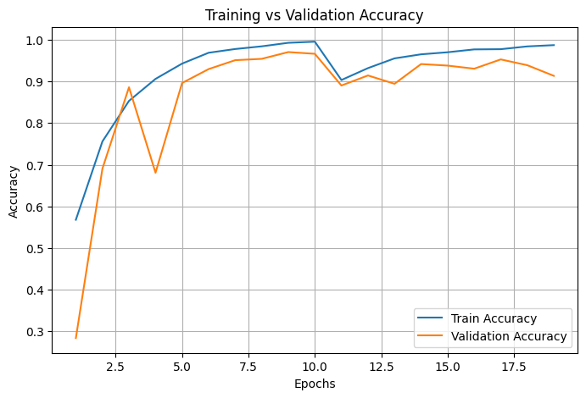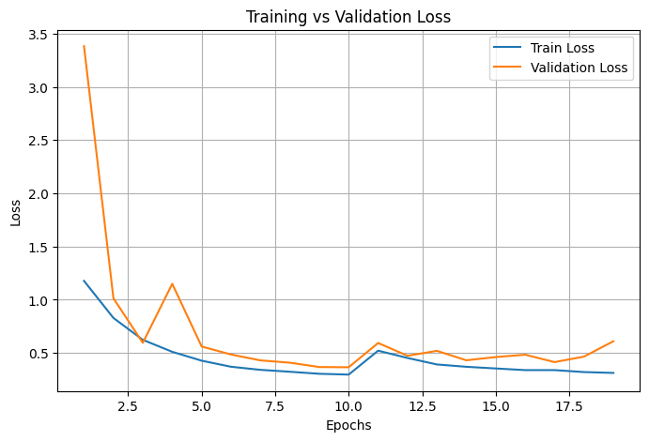✅ Final model saved successfully
Confusion Matrix :
from sklearn.metrics import confusion_matrix
import seaborn as sns

cm = confusion_matrix(ty, tp)

plt.figure(figsize=(8,6))
sns.heatmap(
cm,
annot=True,
fmt="d",
cmap="Blues",
xticklabels=classes,
yticklabels=classes
)
plt.xlabel("Predicted Label")
plt.ylabel("True Label")
plt.title("Confusion Matrix for Blood Group Classification")
plt.tight_layout()
plt.show()
Output :
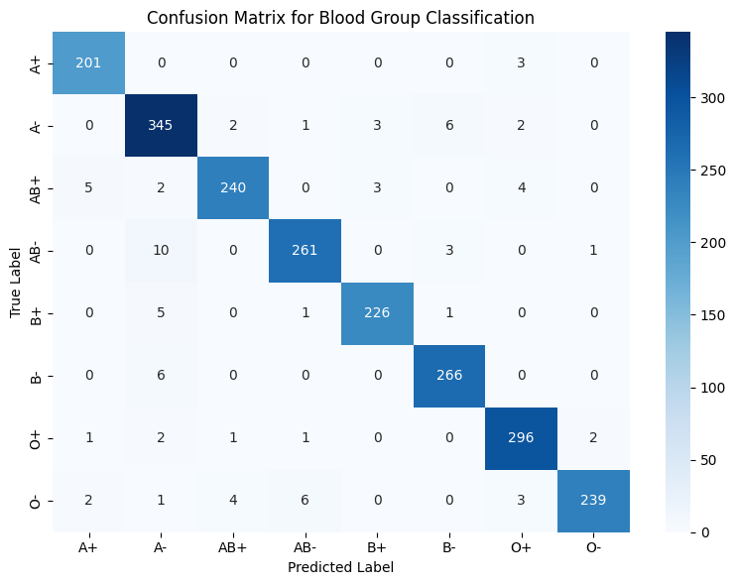
ROC Curve:
from sklearn.preprocessing import label_binarize
from sklearn.metrics import roc_curve, auc

y_bin = label_binarize(ty, classes=range(len(classes)))

plt.figure(figsize=(8,6))
for i, cls in enumerate(classes):
fpr, tpr, _ = roc_curve(y_bin[:, i], np.array(tp) == i)
roc_auc = auc(fpr, tpr)
plt.plot(fpr, tpr, label=f"{cls} (AUC={roc_auc:.2f})")

plt.plot([0,1], [0,1], 'k--')
plt.xlabel("False Positive Rate")
plt.ylabel("True Positive Rate")
plt.title("ROC Curves for Blood Group Classification")
plt.legend()
plt.grid(True)
plt.show()

Output :
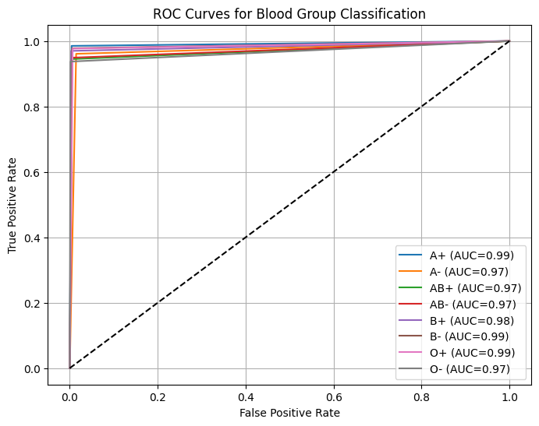
Metric:
macro_precision = report["macro avg"]["precision"]
macro_recall = report["macro avg"]["recall"]
macro_f1 = report["macro avg"]["f1-score"]
accuracy = accuracy_score(ty, tp)

pd.DataFrame({
"Metric": ["Accuracy", "Macro Precision", "Macro Recall", "Macro F1-Score"],
"Value": [
f"{accuracy*100:.2f}%",
f"{macro_precision:.4f}",
f"{macro_recall:.4f}",
f"{macro_f1:.4f}"
]
})

Output :
 | Metric | Value
0 | Accuracy | 96.24%
1 | Macro Precision | 0.9646
2 | Macro Recall | 0.9628
3 | Macro F1-Score | 0.9635

